 | Year 11 ATAR Human Biology  Task 10 – Genetic Studies

Name: | Teacher:  Ms Langford-Davis | Date: | Score:  Part A = /17  Part B = /23  Total = /40
Assessment type: Science Inquiry - Investigation

Conditions

Time for the task:
- Part A: Planning (one lesson) and conduction of investigation (one lesson) carried out in prior lessons. (Completion of variables, materials, method and table of results of the scientific report, should be completed at home prior to the in-class assessment).
- Part B: One hour in class assessment – Completion of the graph, analysis and evaluation of data of the scientific report (test conditions)

Task weighting – 10%
______________________________________________________________________________
Part A: Planning and conduction of investigation
You will be required to plan, conduct and evaluate an investigation evaluating whether dominant traits are more frequent in a population than recessive traits. You will write up your investigation as a scientific report. (17 marks)
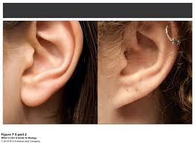
Introduction

Are dominant traits more frequent than recessive traits?
There are several easily observable traits which can be studied in humans. The ones you will study in this task are shown in the table to the right, and explained below.
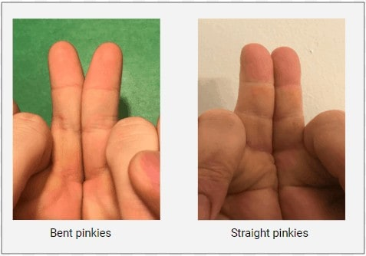
Earlobes
If your earlobes are detached, even partially, from the side of your face, you have the trait ‘detached earlobes’. If your earlobes are attached to the side of your face you have the trait ‘attached earlobes’.
Straight little finger and bent little finger
Hold your hands side by side with your little fingers together. If the end joint of your little finger bends inward, you have the trait ‘bent little finger’. If your little finger is straight, you have the trait ‘straight little finger’.
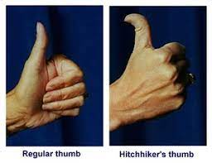
Hitchhiker’s thumb and straight thumb
Make a fist with your thumb extended. If the end section of your thumb extends at an angle of almost 90 degrees from your thumb, then you have the trait ‘hitchhiker's thumb’. If the end section extends at an angle of less than 45 degrees out from the rest of your thumb, then you have the trait ’straight thumb’.
Plan the investigation

Things to consider when planning your investigation:
- devise a hypothesis and choose dependent and independent variables for your investigation
- identify variables to control
- decide upon the appropriate sample size, trials and data collection methods
- describe, in detail, the methodology you will use during your investigation
- decide upon the data recording method.
Conduct the investigation
- Carry out data collection from test subjects in class.

Commence writing the scientific report
Description | Marks
Aim  What you will be investigating | 0.5
Background information  Scientific background or information relevant to the investigation  – must be fully referenced. | 1  0.5
Question  State the question you will be investigating | -
Hypothesis  Write a hypothesis for your investigation question (must include both variables)  This is supported and linked to background information | 1  1
Variables  State the following variables:  - Independent variable and Dependent variable  - Controlled variables | 1  1
Materials  Include a list of materials/equipment used in the investigation | -
Method  Clear and concise step-by-step instructions to carry out the investigation. Control and experimental treatment clearly distinguished. Method ensures reliability and validity. Include a diagram or photograph of your equipment set up if appropriate  Sample size and number of trials if appropriate are included in the method | 3  1
Safety/Ethical considerations  Identify any safety procedures or ethical consideration you need to consider | 1
Subtotal | 11
Collection and processing of results
Results  Records data in an appropriate format;  - Includes appropriate headings and units  - Groups relevant data  - Records repeat trials/all subjects data | 1  1  1
Carries out simple processing of raw data:  - calculates mean values  - uses appropriate format for recording data | 1  1
Identifies and comments on any outliers in the raw data | 1
Subtotal | 6
Total | 17
You should bring your Planning and Write-up of the scientific report up to and including ONLY the components listed above, to the in-class assessment to assist you with Part B.
End of Part A

